Remote hearings at ACAT
What is a remote hearing?
A remote hearing uses technology to allow parties to appear at a hearing without having to attend ACAT’s premises.
Conduct of remote proceedings
Hearings conducted remotely are still formal hearings. All usual etiquette, protocols, procedures and restrictions apply.
Proceedings are recorded. For this reason, it is important that you state your name before speaking each time. This assists our transcription provider who is unable to see video footage of the hearing.
Contact details for a remote hearing
Contact details for the remote hearing will be provided by the ACAT prior to your hearing date. You can use a range of options to connect to the remote hearing.
Setting up your device or laptop prior to a remote hearing
If you are going to video conference into the remote hearing using the Cisco Webex weblink please:
- Ensure your device has a working camera.
- Ensure that your device has reliable internet connectivity and coverage.
- Note your access may vary in quality related to which browser and version you are using ie Google Chrome, Firefox, Internet Explorer or Microsoft Edge.
- Click the Webex weblink 10 minutes prior to your listed appearance time to check your connection. Remember the audio will be live when you connect.
How to join a Webex meeting
The ACAT is using Cisco Webex to establish remote hearings.
You will receive an email from ACAT with the meeting details about how to join the meeting.
A screenshot of what the information looks like is provided below.
- Join meeting- If you have internet access and a device with a camera and microphone you simply need to click on the green ‘Join meeting’ tab to join the conference.
- Telephone -Dial the supplied telephone number. At the prompt enter the Meeting number.
- Video Conference - If you are at a site with video conferencing capability dial the supplied SIP or SIP IP address.
- Microsoft Lync or Skype for Business – Use this log-in if you have these applications. Note it has to be Skype for Business. Normal Skype cannot dial SIP addresses.

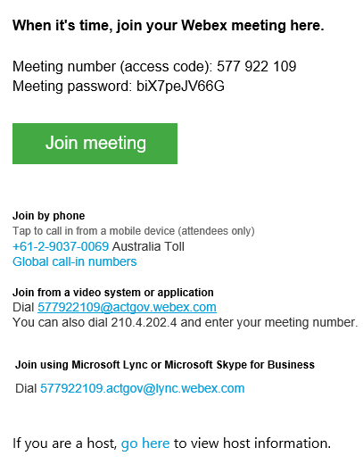
4. Lync or Skype for business
Meeting number
1.Click
3. SIP address
2. Telephone
Trouble Shooting
It is expected that parties may experience some difficulties when using a remote hearing for the first time.
Parties are asked to be patient while a remote hearing is established.
Please call (02) 6207 1740 if you have any trouble accessing the hearing.

