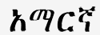  Amharic |  | Arabic |  | 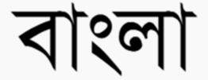  Bengali
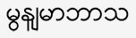  Burmese |  | 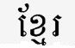  Cambodian |  | 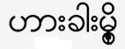  Chin
廣東話  Cantonese |  | 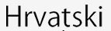  Croatian |  | 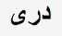  Dari
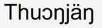  Dinka |  | 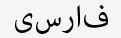  Farsi |  | 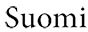  Finnish
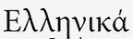  Greek |  | 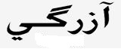  Hazaragi |  | 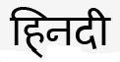  Hindi
  Hmong |  |   Hokkien |  | 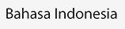  Indonesian
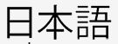  Japanese |  | 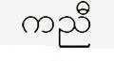  Karen |  | 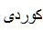  Kurdish
  Lao |  | 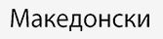  Macedonian |  | 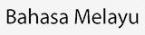  Malayan
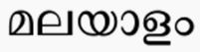  Malayalam |  | 普通话  Mandarin |  | 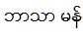  Mon
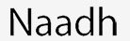  Nuer |  | 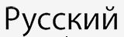  Russian |  | 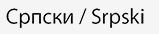  Serbian
  Sinhalese |  | 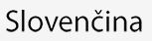  Slovak |  | 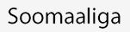  Somali
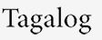  Tagalog/Filipino |  | 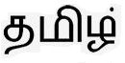  Tamil |  | 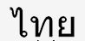  Thai
Tibetan |  | 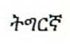  Tigrinya |  | 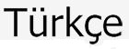  Turkish
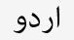  Urdu |  | 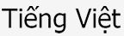  Vietnamese

